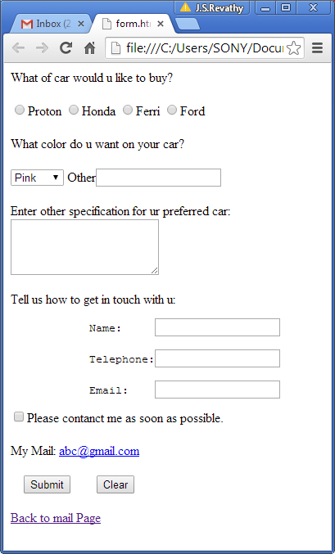

Check whether radiobox checked

Display selected color

If nothing selected in select box, specify color here.

Specification

1. Empty
2. Min<10
3. Max >15

Use regular expression to check name

Must be numbers

[char@char.char](mailto:char@char.char)

check whether it is checked.